According to the Canadian Wildland Fire Information System (CWFIS), British Columbia (BC) has recorded 1.4M wildfires over the past 10 years.

Thanks to the data collected by multiple satellite sources, such as AVHRR, MODIS, and VIIRS, we now know how serious this problem is. Even though satellites are highly accurate technology, some information was missing. To solve this problem, we deleted the N/A values and converted the necessary data types.

If you want to know the causes of BC's wildfires, we did some Exploratory Data Analysis which included analyzing key statistics such as averages, frequencies, and correlation coefficients, to uncover patterns and relationships within the data. The causes are:

* British Columbia’s vegetation is mostly composed of Coniferous Forest Fuel Types (C1 to C7) and bog, which means it is persistent to fire and difficult to extinguish.
* From the analysis it’s known that trees in the province are mostly leafless, affecting available fuel.
* In 2017, 2018, and 2021 precipitations reached the lowest point in the past 10 years, coincidentally those were the years with more wildfires.

If you’re really in love with this province as we are, you’ll get a sense of how important is the ecosystem for BC-ians. For 10yrs MU, Inc. has been studying wildfire behavior and come up with an amazing idea, which would be the anti-wildfire spray.

From our work in the field, we know that there is a negative but moderate correlation between Drought Code and the Age of the trees, specifically –0.4. So, in that sense, we have created a product to rejuvenate older trees and make them moister.

The product will moisturize the decomposed organic layers, important for smoldering fires, that would result in the that would result in less spread of wildfires and potentially mitigating wildfire ignitions. Based on the data, it has been shown that moisture levels in British Columbia are lower compared to other provinces. Addressing this issue could help mitigate potential problems in BC for the next decade.

Never let a wildfire happen again. Visit our website to schedule your free product demo at your closest park.

**MU, Inc.**

**Appendix**

install.packages(c("dplyr", "tidyr", "ggplot2", "lubridate"))

library(dplyr)

library(tidyr)

library(ggplot2)

library(sf)

library(lubridate)

# Path of the folder containing the CSV files

path <- "D4800_Proj2_Data/"

# Get a list of all CSV files

files <- list.files(path, pattern = "*.csv", full.names = TRUE)

# Function to read each CSV file and normalize column names

read_and_normalize <- function(file) {

data <- read.csv(file) # Read the CSV file

colnames(data) <- tolower(colnames(data)) # Convert column names to lowercase

return(data) # Return the normalized data frame

}

# Load all data sets and combine them into one

combined_data <- bind_rows(lapply(files, read_and_normalize))

#----------------- DATA CLEANING ----------------------

# Remove records with NA values for latitude and longitude

combined_data <- combined_data %>%

filter(!is.na(lat), !is.na(lon))

# Handle varying formats dynamically

combined_data$rep_date <- parse_date_time(

combined_data$rep_date,

orders = c("Y-m-d H:M:S", "Y-m-d H:M:S.OS", "Y-m-d H:M", "Y-m-d")

)

# Clean agency non-response

combined_data$agency[combined_data$agency == "-"] <- NA

# Replace "" and "unknown" values in the fuel column with NA

combined_data$fuel[combined_data$fuel == ""] <- NA

combined_data$fuel[combined_data$fuel == "unknown"] <- NA

#-------------------- Exploratory Data Analysis -------------------

# Count the number of hotspots per province/territory

province_counts <- table(combined_data$agency[!is.na(combined_data$agency)])

# Sort the province counts in descending order

sorted_province_counts <- sort(province_counts, decreasing = TRUE)

# Select the top 10 provinces

top_10_provinces <- sorted_province_counts[1:10]

# Calculate a dynamic ylim to give extra space above the bars

max_value <- max(top_10_provinces)

ylim_value <- max_value * 1.3

# Create the bar plot for the top 10 provinces

bar_positions <- barplot(top_10_provinces,

main = "Top 10 Provinces with Most Hotspots", # Add a descriptive title

xlab = "Province/Territory", # Label the x-axis

ylab = "Number of Hotspots", # Label the y-axis

col = heat.colors(10), # Use a gradient color palette

las = 2, # Rotate x-axis labels for better readability

border = "gray", # Subtle border color

ylim = c(0, ylim_value), # Dynamically set Y-axis limit

yaxt = "n") # Suppress Y-axis values

# Add a grid for better readability

grid(nx = NA, ny = NULL, col = "gray", lty = "dotted")

# Add exact counts on top of the bars with proper alignment

text(x = bar_positions,

y = top_10_provinces,

labels = top_10_provinces,

pos = 3, offset = 0.5, cex = 0.8, col = "black") # Offset added for better visibility

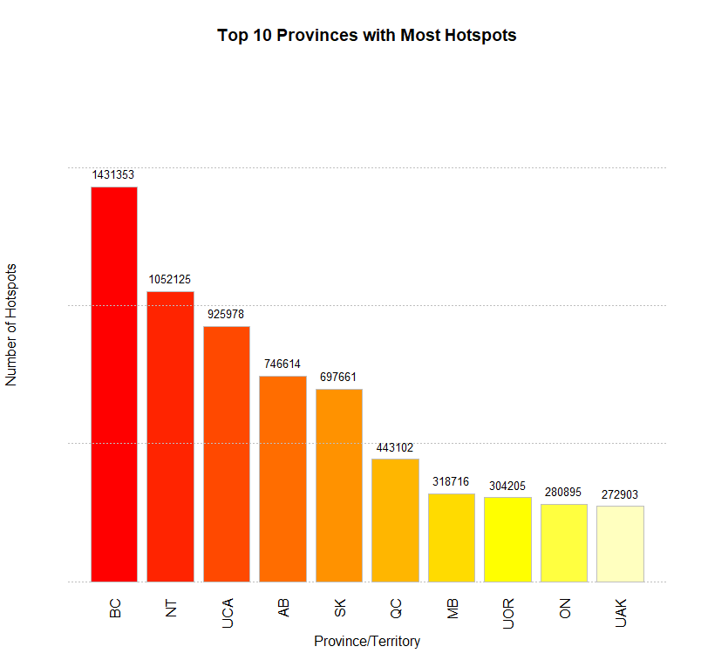

# Filter data for the top 10 provinces

top_province_names <- names(top_10_provinces)

# Get the top 10 provinces/territories with the most hotspots

top_10_agencies <- names(top_10_provinces)

filtered_data <- combined_data %>%

filter(agency %in% top_10_agencies)

# Convert the 'fuel' column to a factor and drop unused levels

filtered_data$fuel <- factor(filtered_data$fuel)

filtered_data$fuel <- droplevels(filtered_data$fuel)

# Create a contingency table between 'agency' and 'fuel' for the top 10

contingency_table <- table(filtered_data$agency, filtered_data$fuel)

# Perform the chi-square test

chi_square_test <- chisq.test(contingency_table)

# Print the test results

print("Chi-Square Test Results:")

print(chi_square_test)

# Normalize fuel type counts by calculating the proportion for each agency

fuel_type_proportions <- combined_data %>%

filter(agency %in% top_province_names, !is.na(fuel)) %>%

group_by(agency, fuel) %>%

summarize(count = n(), .groups = "drop") %>%

group_by(agency) %>%

mutate(proportion = count / sum(count)) %>%

ungroup()

# Stacked bar chart for normalized fuel type proportions

ggplot(fuel_type_proportions, aes(x = agency, y = proportion, fill = fuel)) +

geom_bar(stat = "identity") +

scale_fill_viridis_d() +

labs(

title = "Normalized Fuel Type Distribution in Top 10 Provinces",

x = "Province/Territory",

y = "Proportion of Fuel Type",

fill = "Fuel Type"

) +

theme_minimal() +

theme(axis.text.x = element_text(angle = 45, hjust = 1))

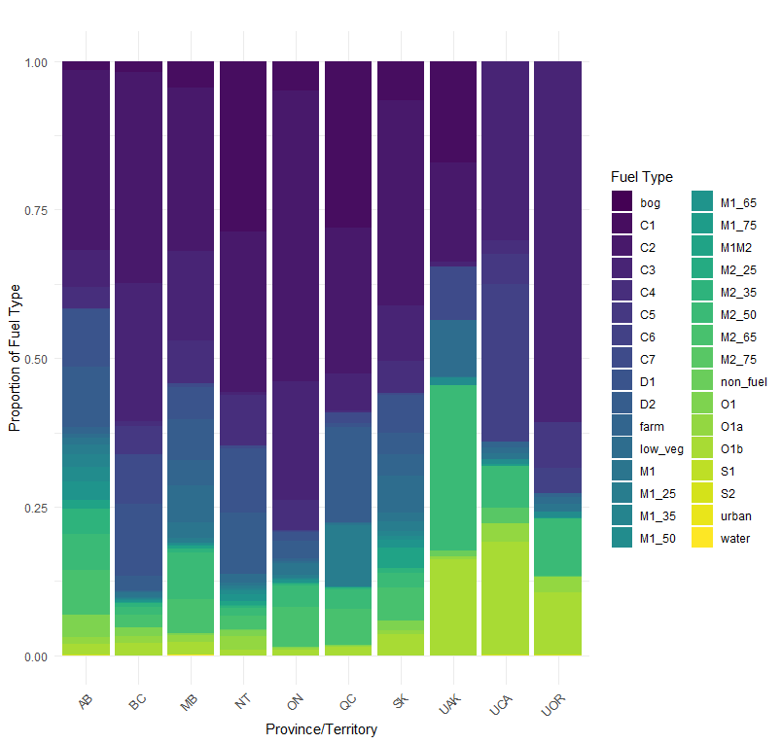

# Calculate the proportion of 0 and 1 greenup for each province

greenup_proportions <- combined_data %>%

filter(agency %in% names(top_10_provinces)) %>%

filter(!is.na(greenup)) %>%

group_by(agency, greenup) %>%

summarize(count = n(), .groups = "drop") %>%

group_by(agency) %>%

mutate(proportion = count / sum(count))

ggplot(greenup_proportions, aes(x = agency, y = proportion, fill = as.factor(greenup))) +

geom_bar(stat = "identity") +

scale_fill_manual(values = c("0" = "gray", "1" = "green"), labels = c("Leafless (0)", "Green (1)")) +

labs(

title = "Proportion of Greenup (0 = Leafless, 1 = Green) by Province",

x = "Province/Territory",

y = "Proportion",

fill = "Greenup"

) +

theme_minimal() +

theme(axis.text.x = element_text(angle = 45, hjust = 1))

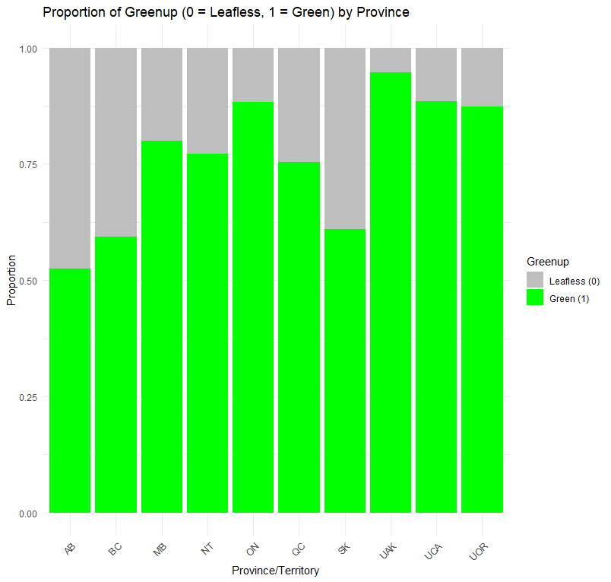

# Filter the data for British Columbia (BC)

bc_data <- combined_data %>%

filter(agency == "BC") %>%

mutate(

year_month = format(rep_date, "%Y-%m") # Extract year and month in "YYYY-MM" format

)

# Extract the year from the 'rep_date' column

bc_data <- bc_data %>%

mutate(year = format(rep_date, "%Y"))

# Calculate the average PCP and the number of hotspots per year

bc_avg_yearly <- bc_data %>%

group_by(year) %>%

summarize(

average_pcp = mean(pcp, na.rm = TRUE), # Average precipitation

average_hotspots = n() # Total hotspots (count of rows)

)

bc_avg_yearly <- bc_avg_yearly %>%

mutate(

scaled_hotspots = average_hotspots / max(average_hotspots),

scaled_pcp = average_pcp / max(average_pcp) # Scale precipitation to [0, 1]

)

# Ensure 'year' is numeric for proper plotting

bc_avg_yearly <- bc_avg_yearly %>%

mutate(year = as.numeric(year)) # Convert 'year' to numeric

# Create the plot

ggplot(bc_avg_yearly, aes(x = year)) +

# Line plot for scaled precipitation

geom_line(aes(y = scaled_pcp, color = "Scaled Precipitation"), size = 1, linetype = "solid") +

geom_point(aes(y = scaled_pcp, color = "Scaled Precipitation"), size = 2) +

# Line plot for scaled hotspots

geom_line(aes(y = scaled_hotspots, color = "Scaled Hotspots"), size = 1, linetype = "dashed") +

geom_point(aes(y = scaled_hotspots, color = "Scaled Hotspots"), size = 2) +

# Labels and title

labs(

title = "Yearly Scaled Precipitation and Hotspots in BC",

x = "Year",

y = "Values (Scaled to 0-1)",

color = "Legend",

caption = "Hotspots and precipitation scaled for comparison"

) +

scale_y_continuous(

limits = c(0, 1), # Ensure both metrics are displayed in the same range

name = "Scaled Values (0 to 1)"

) +

theme_minimal() +

theme(

axis.text.x = element_text(angle = 45, hjust = 1),

axis.title.y = element_text(color = "black"),

legend.position = "bottom"

)

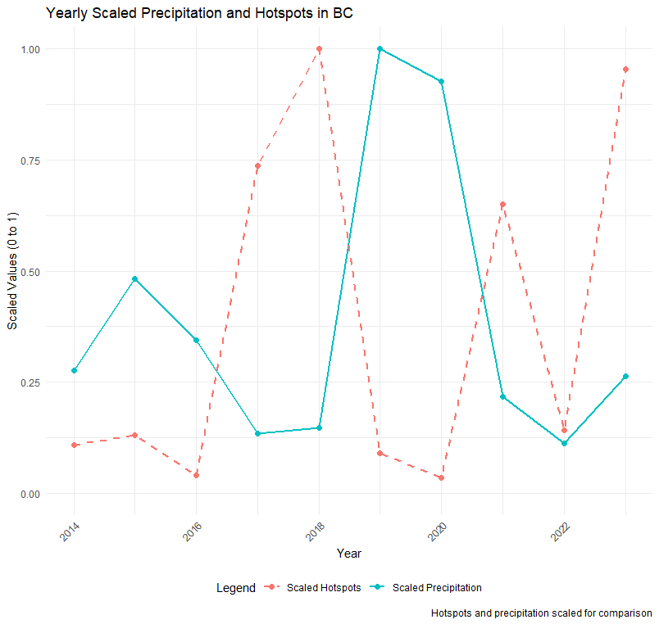

# Filter data for valid DC and age

dc_age_data <- combined_data %>%

filter(!is.na(age), !is.na(dc), agency == "BC") # Remove rows with missing DC or age

# Scatter plot: DC vs Age

# Scatter plot: DC vs Age with regression line

ggplot(dc_age_data, aes(x = age, y = dc)) +

geom_point(alpha = 0.6, color = "darkblue") + # Scatter points

geom_smooth(method = "lm", color = "red", se = TRUE) + # Regression line with confidence interval

labs(

title = "Correlation between Age and Drought Code (DC)",

x = "Age of Vegetation (Years)",

y = "Drought Code (DC)"

) +

theme_minimal()

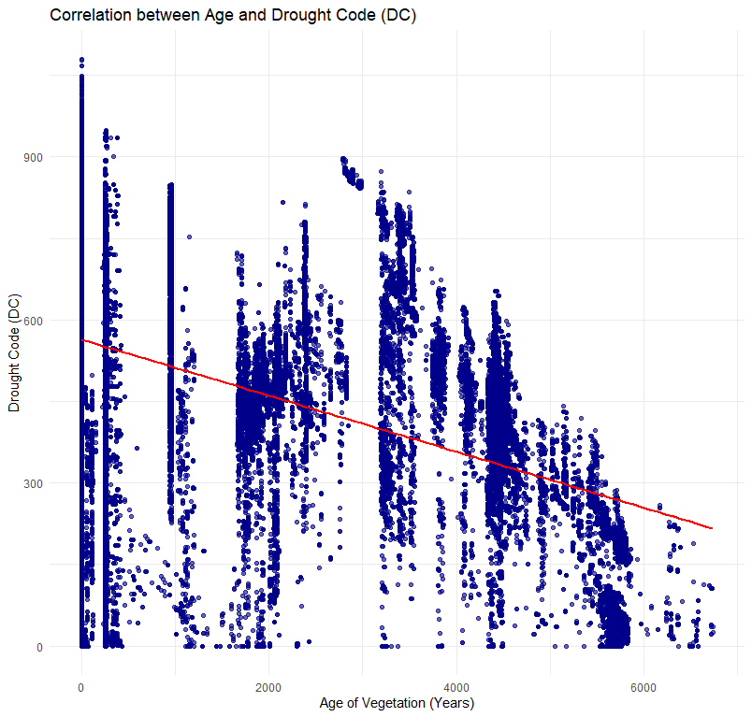

# Print correlation coefficient

correlation_age_dc <- cor(dc_age_data$age, dc_age_data$dc, use = "complete.obs")

print(paste("Correlation coefficient between Age and Drought Code (DC):", round(correlation_age_dc, 2)))

[1] "Correlation coefficient between Age and Drought Code: -0.4"

correlation_age_tfc <- cor(tfc_age_data$age, tfc_age_data$tfc, use = "complete.obs")

print(paste("Correlation coefficient between Age and TFC:", round(correlation_age_tfc, 2)))

# Filter the data for the top 10 provinces and non-NA DMC values

dmc_top_provinces <- combined_data %>%

filter(agency %in% top_province_names, !is.na(dmc)) # Filter for top provinces and non-NA DMC

# Create a boxplot for DMC by province

ggplot(dmc_top_provinces, aes(x = reorder(agency, -dmc), y = dmc, fill = agency)) +

geom_boxplot(show.legend = FALSE, outlier.color = "red", outlier.size = 1.5) + # Boxplot with outlier styling

scale_fill_viridis_d() + # Use a visually appealing color palette

labs(

title = "Distribution of Duff Moisture Code (DMC) for Top 10 Provinces",

x = "Province/Territory",

y = "Duff Moisture Code (DMC)"

) +

theme_minimal() +

theme(

axis.text.x = element_text(angle = 45, hjust = 1) # Rotate x-axis labels for readability

)

